30. Population Growth and Regulation *(Chapter 51, 52)*

______________________________________________________________________________

I. Introduction to Ecology *(1193-1195, 1222-1225)*

# A. Definition

-Ecology is the study of all the relationships between organisms and their environments

-Abiotic (physical)

-Biotic (other organisms)

B. Four Perspectives on Ecology

-Biossphere:

-Ecosystems

-ecological communities and environment

-Community Enology

-Groups of populations that live together

-Have emergent properties that individual properties do not have

-Population Ecology

-Interactions between populations/interbreeding

-Physiological Ecology

C. Central Questions in Ecology

-What limits the sizes and geographical distribution of species?

-Why are there so many species and how are they organized into communities?

-How do human activities disrupt…

-How do we preserve what’s left

II. Unlimited Population Growth *(1232-2333)*

A. Reproduction

B. Geometric Population Growth

-Bacterial cell division- every 20 min a bacterium will undergo binary fission and produce two daughter cells

-N = population size

-Delta N = change in N

-t = time interval

-At t = 0, N = N_0

-At t = 1, N = N_1

-N_t = population size at some future time

-R_0 = replacement rate 🡪 number of offspring an individual leaves behind

-R for bacteria is 2 because they undergo binary fission (R_0 =2)

-At t = 0, N_0 = 1

-At t = 1, N_0 = 2

-At t = 2, N_0 = 3

-N_1 = R_0*N_0

-N_2 = R_0*N_1 = R_0*R_-*N_0

-N_3 = R_O*N_2=R*_0*R_0*R_0*N_0

-N_t = N_0*R_0^t

1. Simplest case: bacterial division

2. Graphical representation

3. Mathematical representation

C. Exponential Population Growth

1. Births and deaths

2. Per capita birth and death rates

-Delta N / time = B – D

-B -absolute number of births

-Absolute number of death

-Births and deaths expressed as per capita rate 🡪 per individual per unit time

b = per capita birth rate = B/N

d = per capita death rate = D/N

B = b*N

D = d*N

Chane in population over a time

Delta N/Delta T = B – D = bN – dN = N(b - d)

(b - d) = r

r is that per capita populiton growth rate

dN/dt=delta N/delta T=rN

-World population in 1959

N = 3*10^9

36 births/1000/yr b = .036/yr

19 death/100/year d = .019/yr

r = b – d = (.036 - .019)/yr = .017/yr

delta N from 1959-1960

delta N/yr = r N = (.017)*(3*10^9) = 51* 10^6

-if r > 0, N increase

-if r < 0 N decrease

-if r = 0 ZPG zero population growth

-Under ideal conditions r = r_max

D. Examples from Human Population Studies

E. Per Capita Growth Rate (*r*) as a Population Characteristic

1. Variations in *r*

2. The intrinsic rate of increase (*r*max)

F. Effects of r on N

III. Limited Population Growth *(1234-1240)*

A. Resource Limitation

1. Resources that can be depleted

2. Crowding

B. Density‑Dependent Responses

C. Logistic Population Growth

1. Sigmoid (= logistic) growth curve

2. Carrying capacity and population regulation

3. Growth of introduced populations

D. Interactions Causing Density‑Dependent Population Regulation

1. Predation

2. Competition

30-1

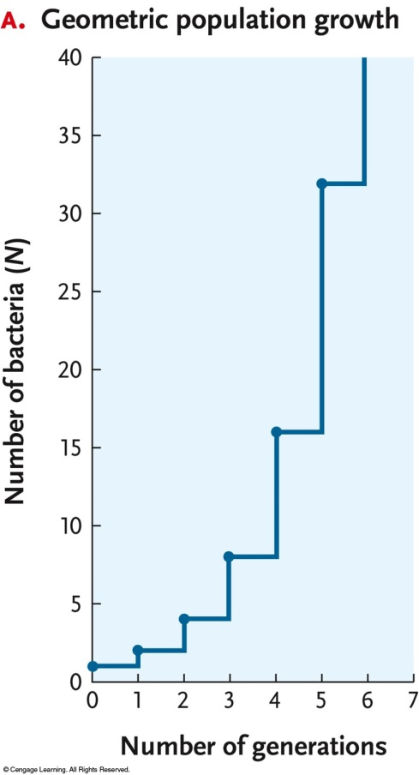

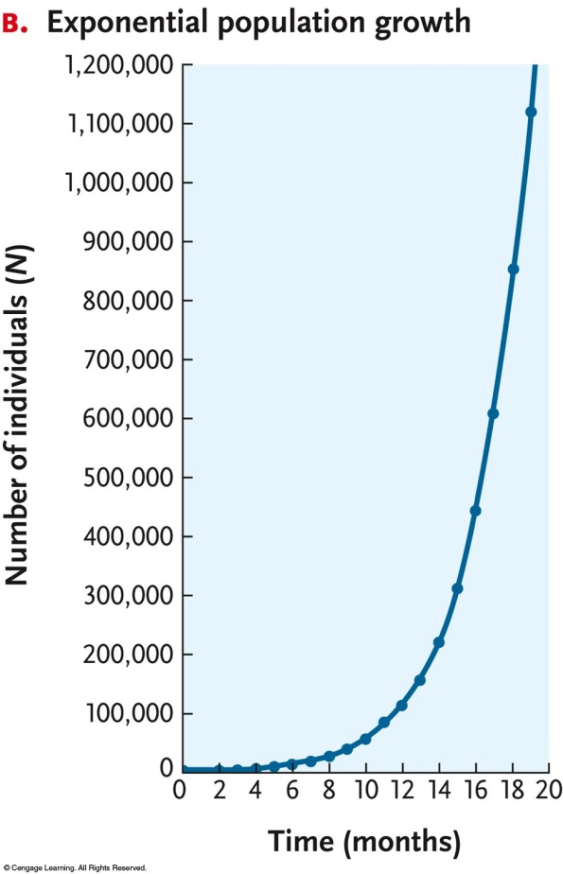

30-2

